Hero Vired - GIT Assignment

Question 1: Project Initialization & First Push
Below are the git commands for creating new app.py file and stage the file and commit
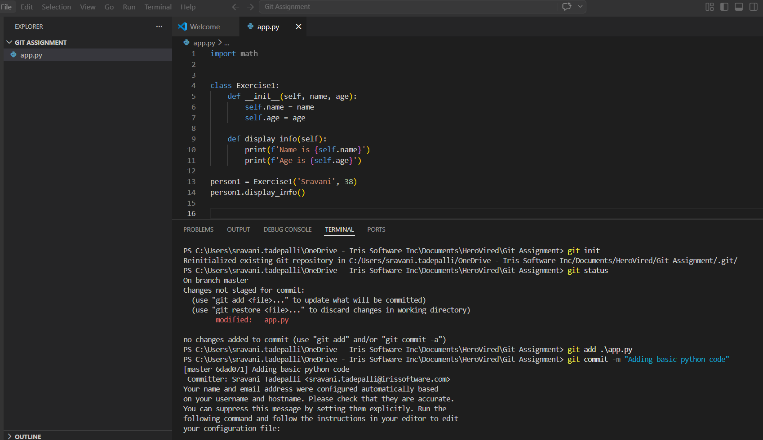
Below are the git command for connecting to remote repository and pushing the app.py file to GitHub remote repository.
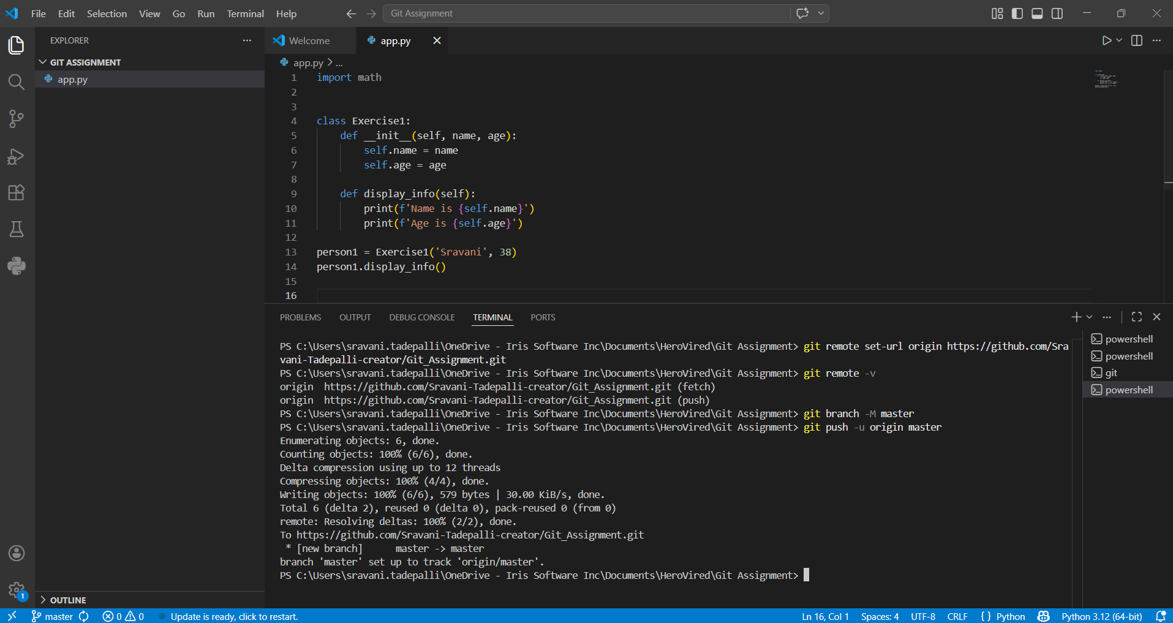
app.py file is added to GitHub repository
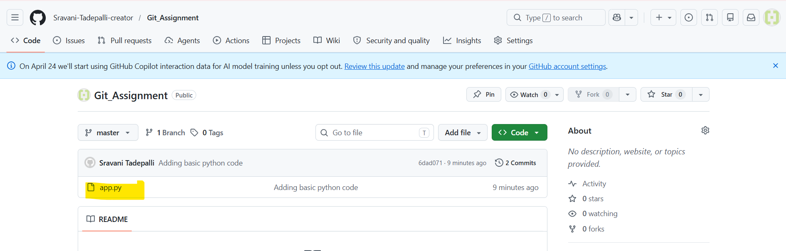

Question 2: Working with Changes & History
Below screenshot shows
- App.py modified
- Showing the difference from last commit
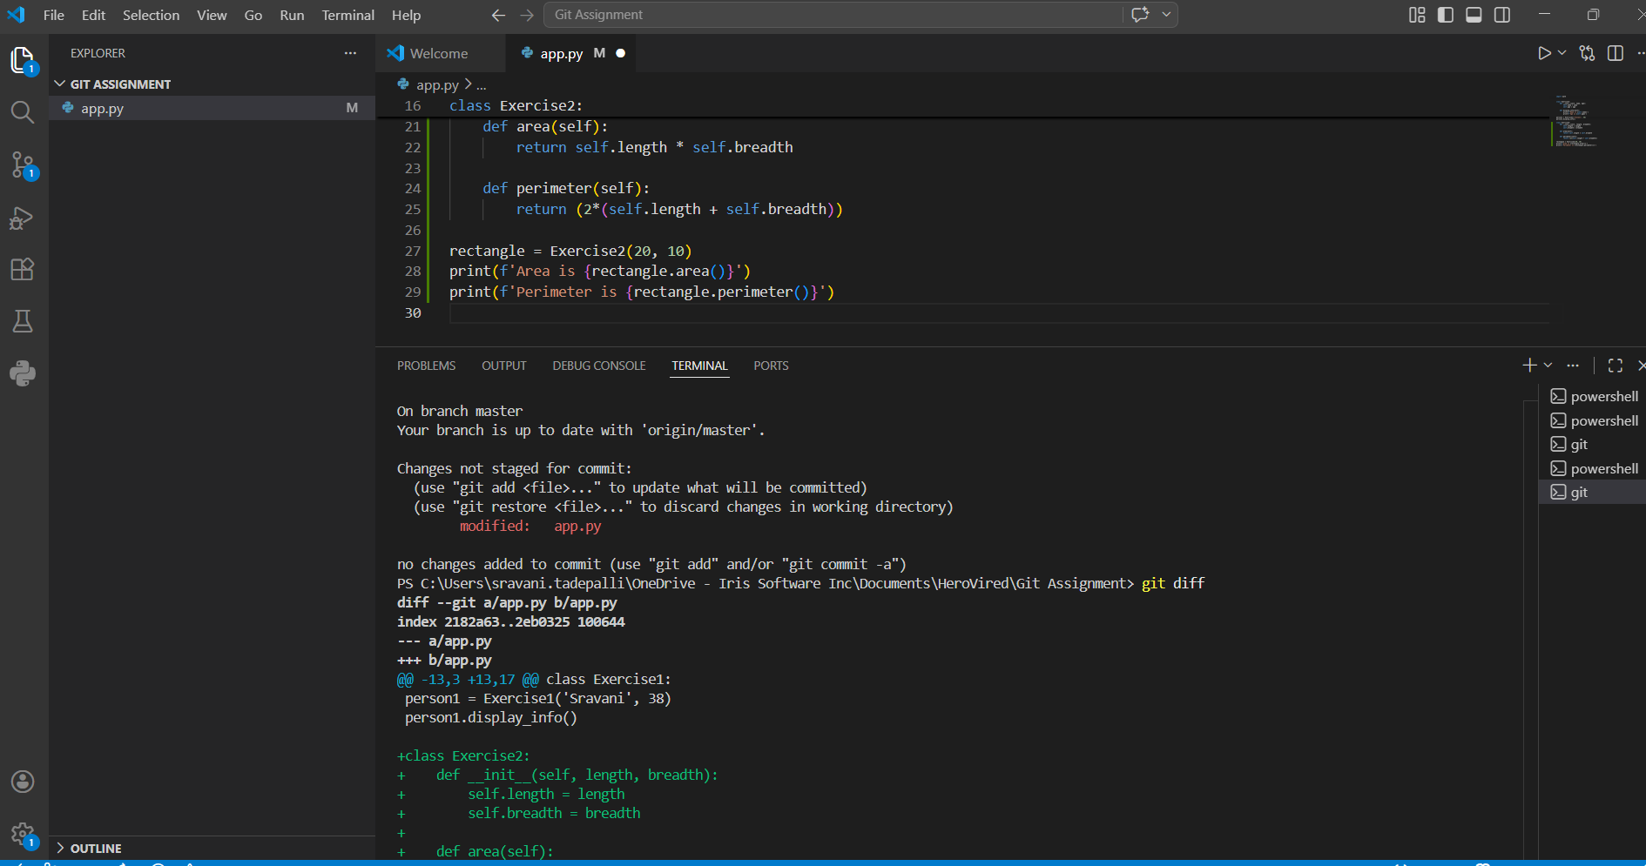

- Modified app.py file
- Staged and committed again
- Full commit history
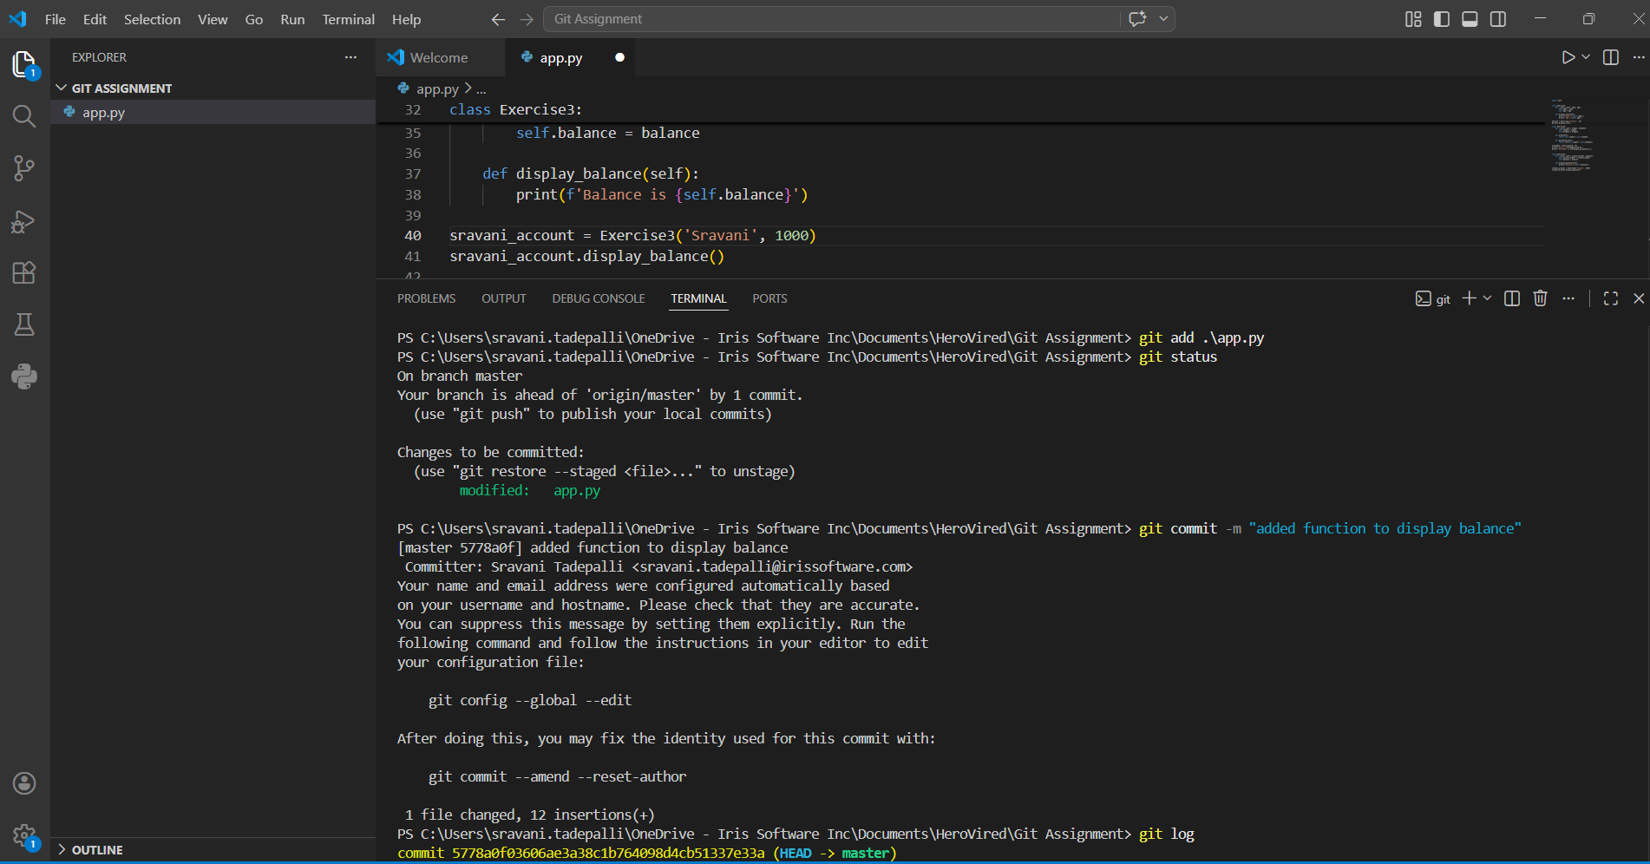

- Compact one line history

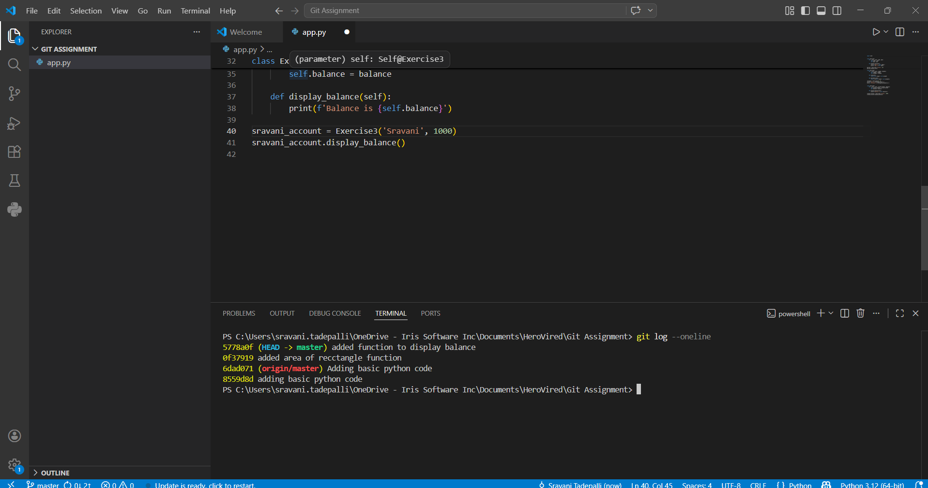

Question 3: Branching & Feature Development
- New feature branch
- Modified code and committed to feature branch
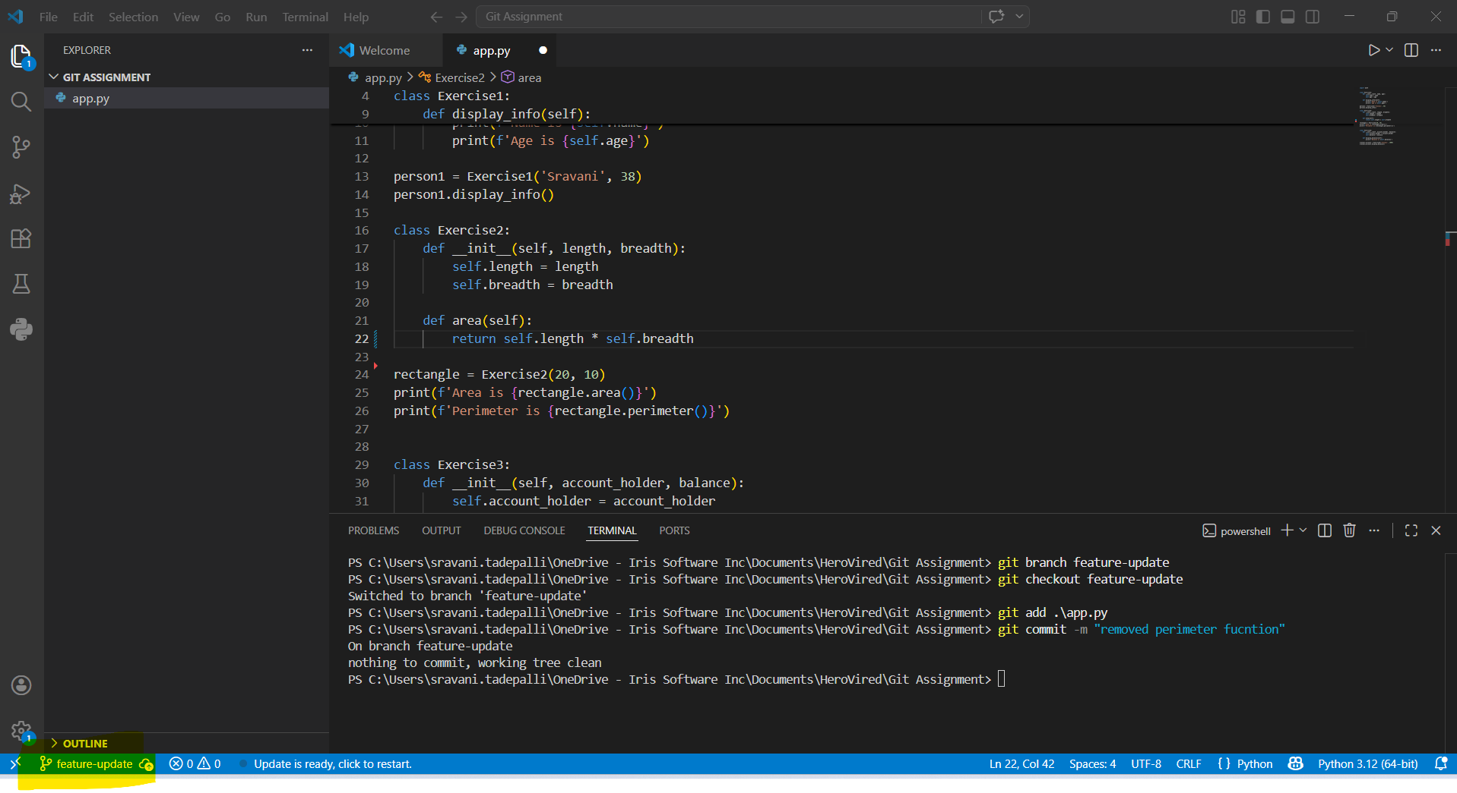
- Merged to Master
- delete feature-update
- delete dummy branch
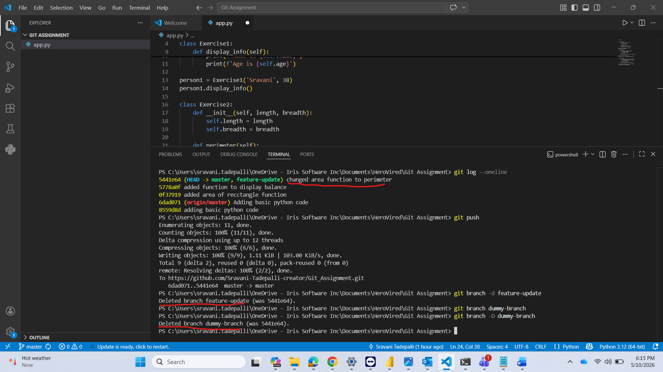
Question 4: Handling Errors (Stash, Reset, Revert)
Stashing the updates and applying them back
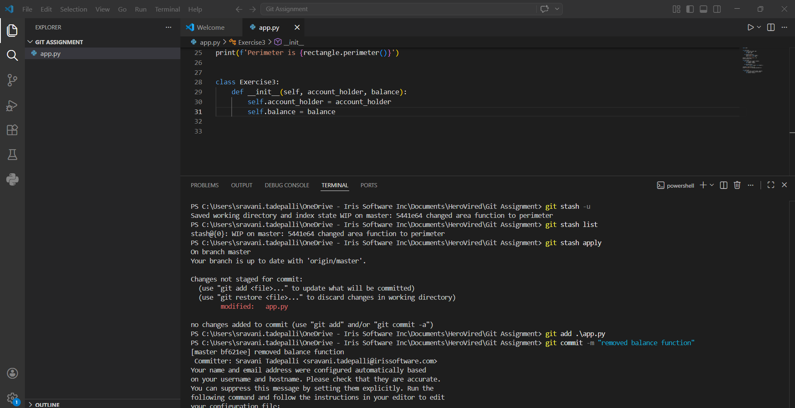

Adding incorrect code and correcting it back
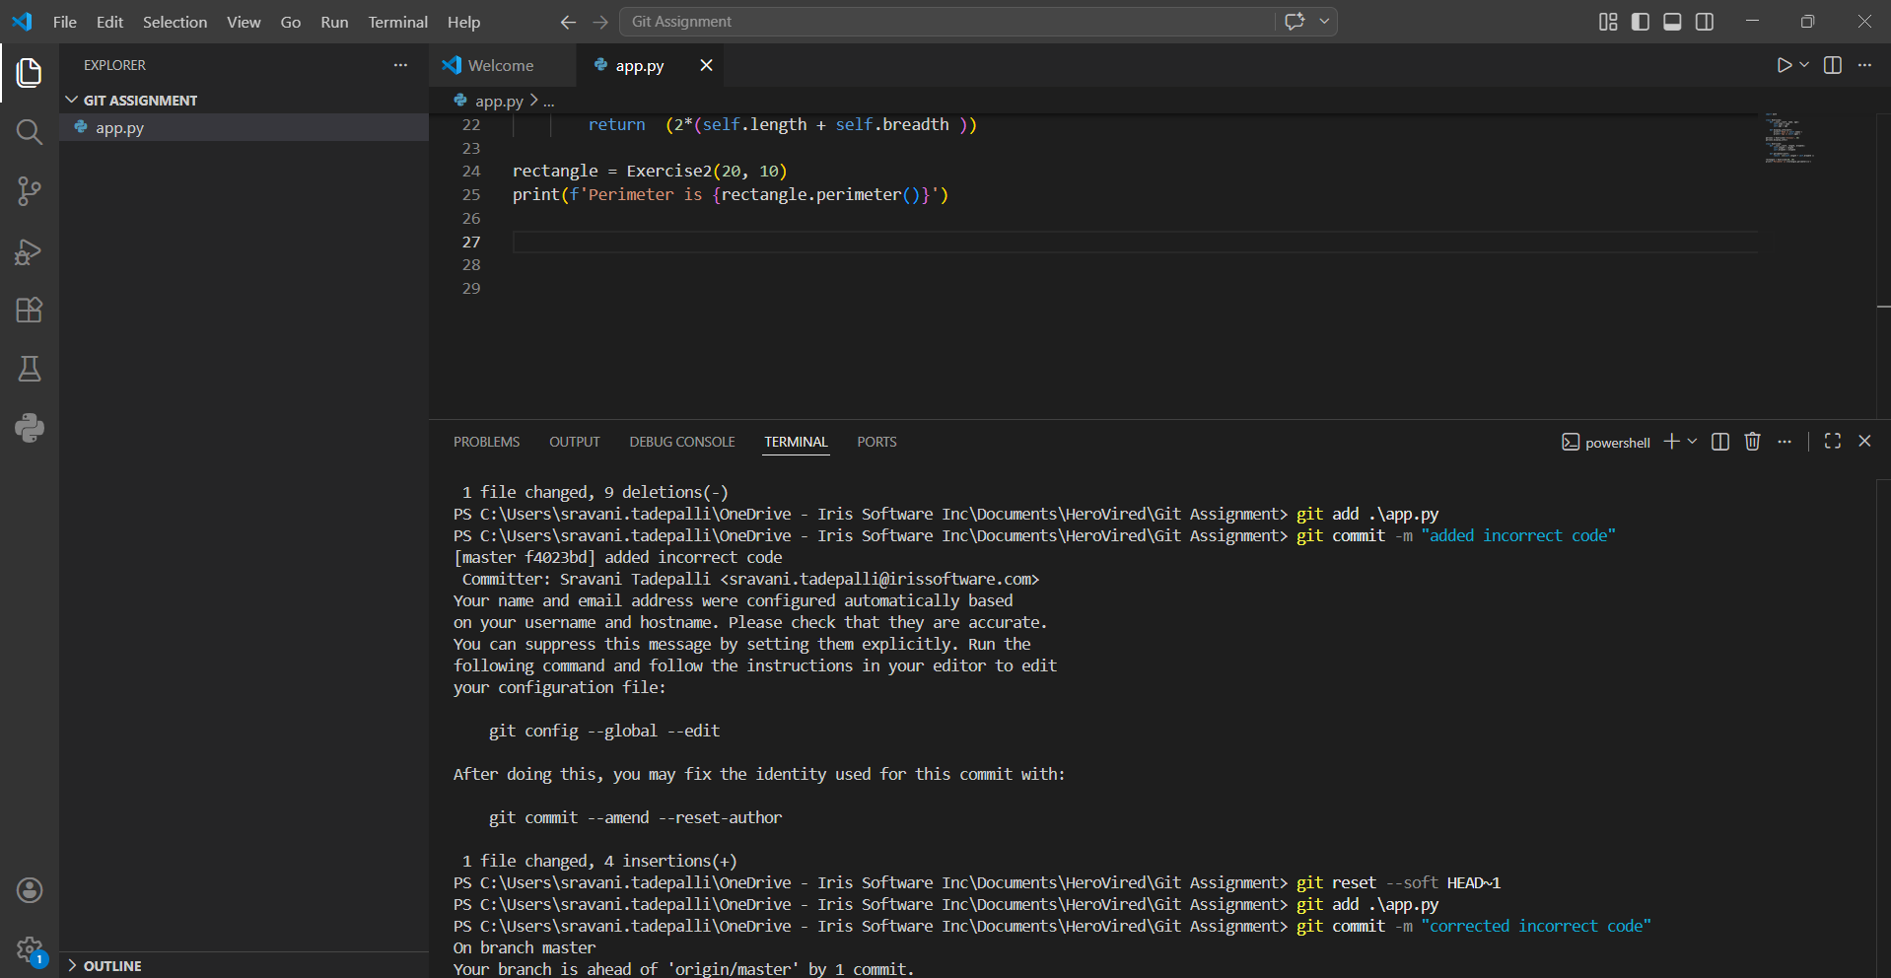

Undo commit using Revert
